**Telecom Churn Analysis**

**Aditi Agrawal,**

**AlmaBetter**

**Abstract:**

Every company tries to get solution for customer churn. Customer churn are the customer who left our service and are no longer associated with our organization.

As Telecom Company has multiple competitors, customer churn is biggest problem in telecom companies.

## Our Analysis can help understand what could be the reason for customer churn in one of such telecom company named as Orange S.A., formerly France Télécom S.A., it is a French multinational telecommunications corporation by feature selection, relating multiple features and analyzing it.

**1. Problem Statement**

Data provided by Telecom Company includes customer activity and customer churn.

**The main objective is to find relation between customer churn and other features. This would in turn help in finding ways to retain existing customers.**

* International plan: If the customer has subscribed for international plan or not
* Voice mail plan: : If the customer has subscribed for Voice mail plan or not
* Number v-mail messages: Number of V-mail sent by customer
* Total day minutes: Total daily day call minutes of customer
* Total day calls: Total daily day call by customer
* Total day charges: Total daily day call charged for customer
* Total eve minutes: Total daily evening call minutes of customer
* Total eve calls: Total daily evening call by customer
* Total eve charges: Total daily evening call charged for customer
* Total night minutes: Total daily night call minutes of customer
* Total night calls: Total daily night call by customer
* Total night charges: Total daily night call charged for customer
* Total intl minutes: Total daily international call minutes of customer
* Total intl calls: Total daily international call by customer
* Total intl charges: Total daily international call charged for customer
* Customer churn: whether the customer left our service (True) our he/she is still using our service (False).
* State: Customer’s location
* Area code: From which area code customer is.
* Customer service calls: Customer service call by customer
* Account length: From how many days customer is taking our service.

**2. Introduction**

### We have different type of customers, some who have subscribed of international plan, some who have subscribed for v-mail plan, according to the state of customer and area code of customer.

We have data of 3333 customers with 20 features.

We charge customer as per the plan they have subscribed for (applicable for v-mail or international plan)

**3. Steps involved:**

* **Exploratory Data Analysis**

After loading the dataset we performed this method by comparing our target variable that is Customer churn with other independent variables. This process helped us figuring out various aspects and relationships among the target and the independent variables. It gave us a better idea of which feature behaves in which manner compared to the target variable.

* **Null values Treatment**

Our dataset do not contains any null values.

* **Categorical columns**

We used groupby() and value_counts() to get count of our categorical features because categorical features that are in string format cannot be understood by the machine and needs to be converted to numerical format.

* **Numerical columns**

We used groupby() and aggregate function to plot numerical features.

# **Data Distribution**

# Almost every data is normally distributed. As per univarient Analysis-

* 14% of customers churn is there.
* 28% of customer subscribed for v-mail plan.
* 10% of customer subscribed for international plan.

# **Relating features with dependent variable (churn)**

In these steps we used different charts to compare our target variable and all independent variable to check which variable are important and affect the target variable.

And it seems like all the variables are important and every variable affects the target variable in some way

* **Account length and churn**
  + Account length does not affect customer churn much

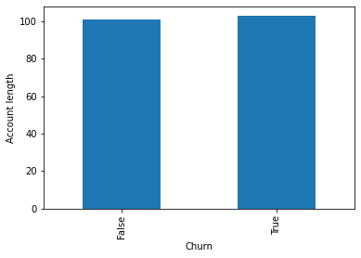

* **V-mail and churn**
  + Customer churn were doing lesser Average v-mails but 8% customer churn were V-mail subscriber.

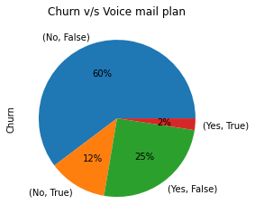

* **Total daily minutes and churn**
  + Total Average daily call minutes of customer churn were high.

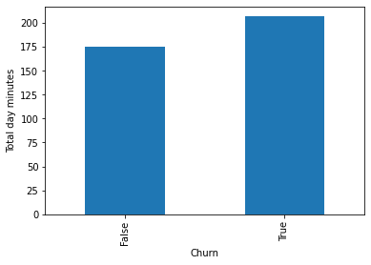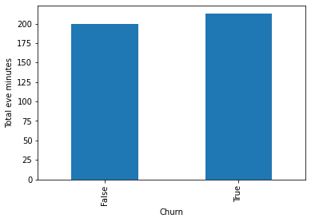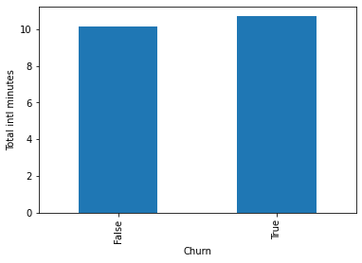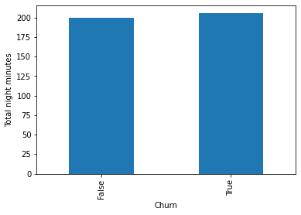

* **Customer call service and churn**
  + Average customer calls of customer churn were high.

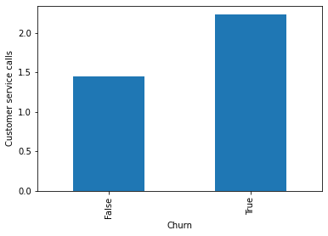

* **Area code and churn**
  + We have maximum users from area code 415.

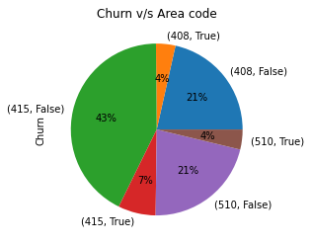

* **International calls and churn**
  + 40% of customers from international plan subscriber are customer churn and customer churn are using international call service more.

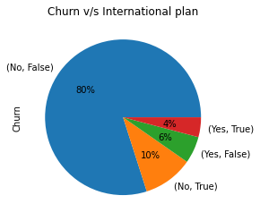

**4. Conclusion:**

* Account length does not affect customer churn much
* Customer churned were calling customer service more
* Average daily call mins of customer churn were high
* 8% v-mail subscribers are customer churn
* 40% international subscriber are customer churn
* We have maximum customers from area code 415.

**5. Ways to ensure customer retention:**

* Improve customer service
* Take feedback of customer service
* Try to solve customer issues asap
* Introducing new plan for customer who talking for longer duration
* We can introduce special plan for Area code from where we are getting high number of customers to retain them and also we can try to get more customers from other areas by introducing plans for new customers
* Make changes in international and v-mail plans
* If we find customer is inactive or any other reason to go churn we can give special offer to retain the customer
* Always keep details of competitors where our customers are going and there services
* If customer if leaving our service try to take feedback from them and improve our service accordingly

.